**Beautiful ALLAH name Prints Frame Set of 3 Calligraphy set**

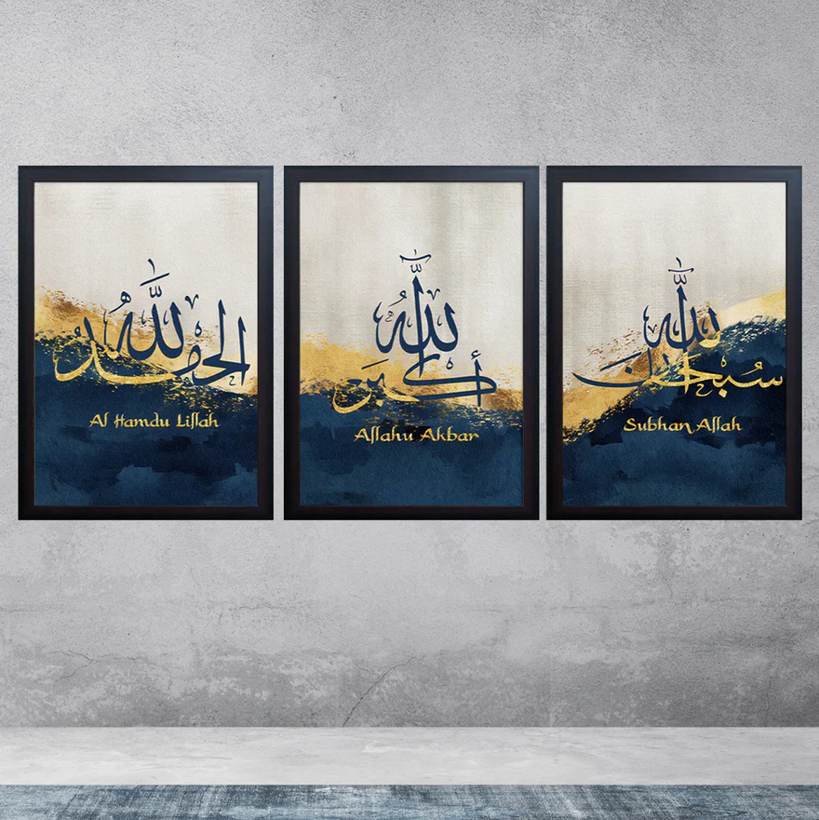A Beautiful Allah Name Prints Frame Set of 3 Calligraphy Set is a stunning collection of artworks that beautifully showcases the sacred names of Allah in elegant Arabic calligraphy. Each print is designed with intricate details, often accompanied by decorative patterns or vibrant colors, making the names of Allah the central focal point of the artwork. These framed prints bring a spiritual and serene atmosphere to any room, symbolizing faith, devotion, and reverence. The frames, usually crafted from high-quality wood or metal, add an elegant touch to the calligraphy, making this set a meaningful and stylish addition to living rooms, bedrooms, or prayer rooms. Perfect for those looking to incorporate Islamic art into their home décor, this set serves as both a reminder of faith and a beautiful piece of cultural art.